

**National Institute of Technology, Calicut**

**Department of Electronics and Communication Engineering**

**EC3093D - Digital Signal Processing Lab**

Experiment – 3 : DTFT, DFT, Magnitude and Phase Plot

Submitted by : Group A-03

Group Members

Adwayith K S B210664EC

Adhyuth Narayan B210650EC

Aditya Tuppad B210038EC

1. Consider a discrete signal x(n) of length N (from 0 to N-1).
2. Generate the DFT and IDFT matrices and show the unitary property.

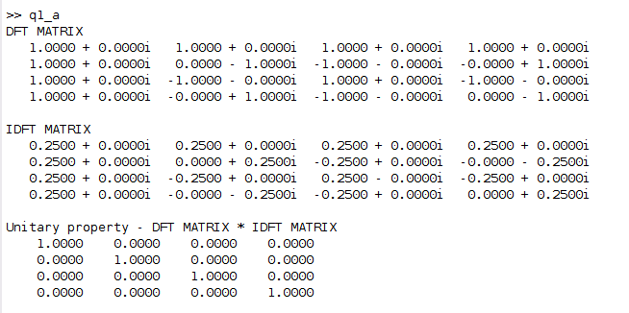

* DFT matrix is a square matrix of size NxN where N is the time period.
* DFT matrix contains the values of the twiddle factor for different values of n and k.
* In this question we took N=4.
* The corresponding DFT matrix and IDFT Matrix are shown above.
* When we multiply the DFT matrix and the IDFT matrix we get an Identity matrix as stated by the unitary property

1. Verify the following properties of DFT using the DFT and IDFT matrices.
2. Duality

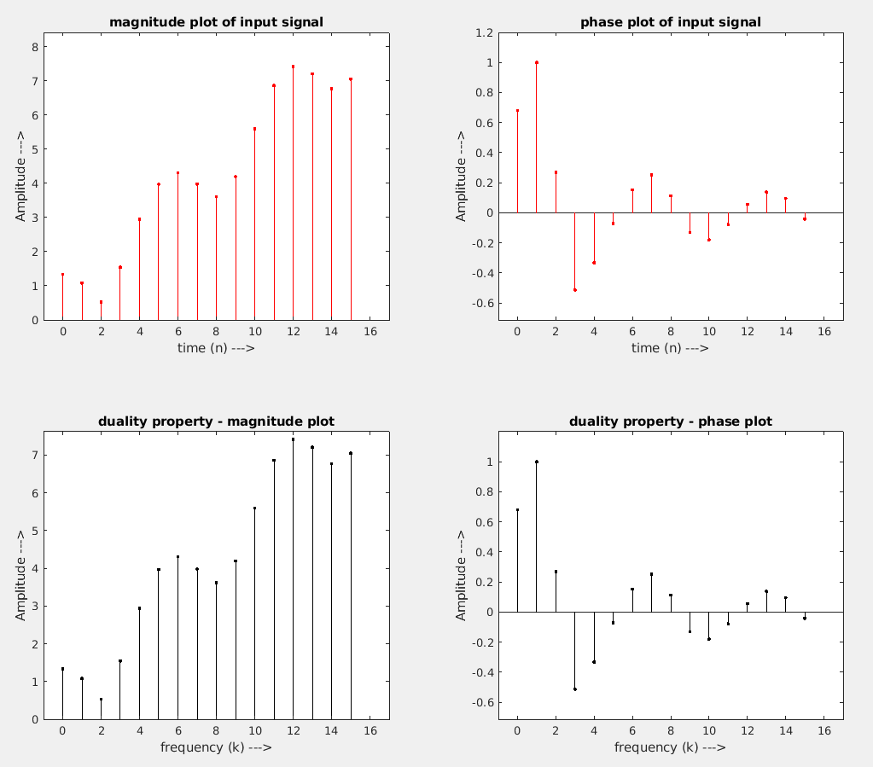

* Duality property states that, if x[n] is an input signal and suppose its DFT is X[k] then the DFT of X[n] is x[N-k].
* In this figure above the DFT x[N-k] is rotated accordingly and plotted so that it resembles the input signal.

1. Time shifting

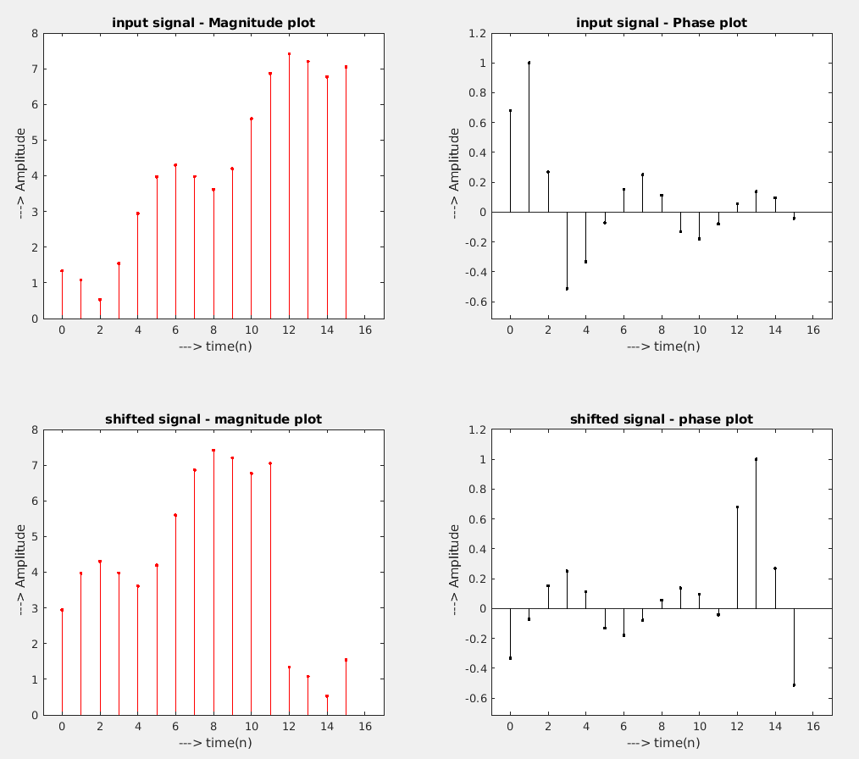

* In the above figure the input signal is a complex signal, this signal is shifted by an amount of 4.
* If x[n] is the input signal then x[n-4] is the output shifted signal.
* According to time shift property if x[n] has a DFT of X[k] then x[n-n0] has a DFT of $X\left[k\right]*e^{\left(-j2πn_{0}k/N\right)}$.
* In the below figure we have plotted DFT of input signal ( X[k] ) and the DFT of output signal multiplied by a factor of $e^{\left(j2πn_{0}k/N\right)}.$
* We can clearly see that both the plots are exactly similar therefore we have successfully proved the time shifting property of DFT.

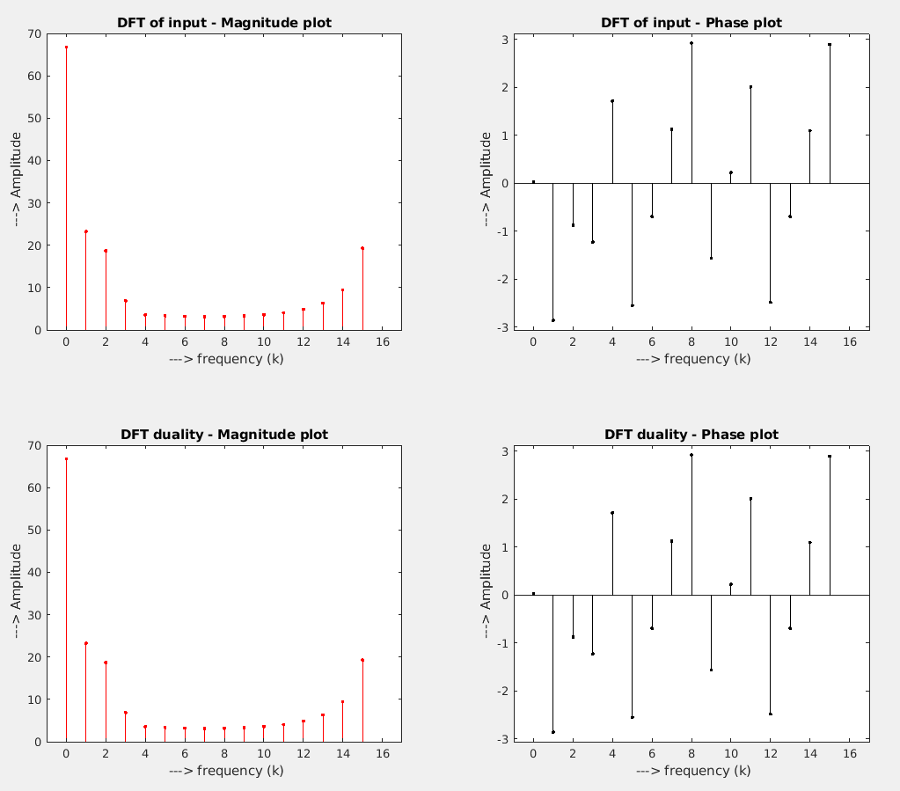

1. Symmetry property. Express the signal x(n) as the sum of conjugate symmetric signal $x_{e}\left(n\right)$ and conjugate anti-symmetric signal $x_{0}\left(n\right).$ Find the DFT of $x_{e}\left(n\right)$ and $x_{0}\left(n\right).$

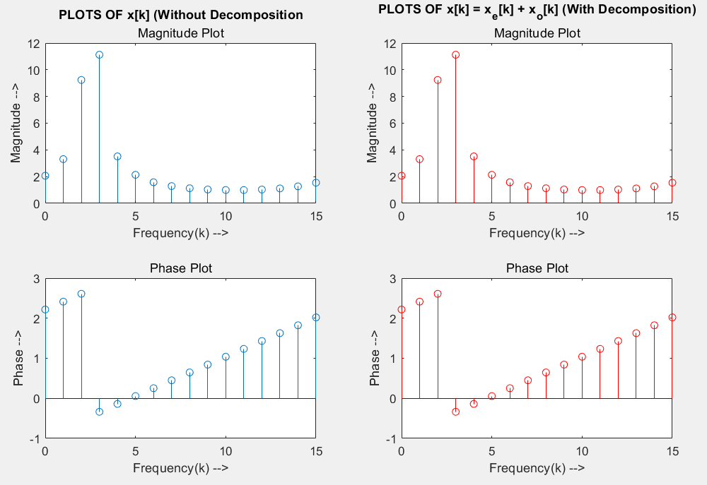

* $x_{e}\left[n\right] and x_{o}\left[n\right]$ are calculated by
$x_{e}\left(n\right)=\frac{1}{2}\left[x\left(n\right)+x^{*}\left(-n\right)\right]$

$x_{0}\left(n\right)=\frac{1}{2}\left[x\left(n\right)-x^{*}\left(-n\right)\right]$

* The magnitude and phase plots with and without the decomposition are observed to be the same

1. Parseval’s Theorem

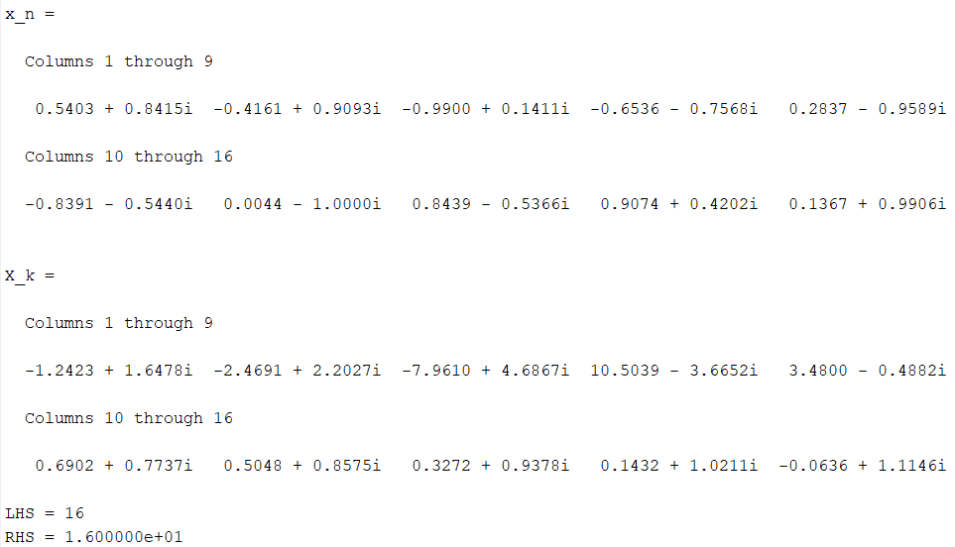

$x(n) = cos(n) + j * sin(n)$

* Parseval’s Theorem - $\sum_{n=0}^{N-1}{{\left|x\left[n\right]\right|}^{2}}=\frac{1}{N}\sum_{k=0}^{N-1}{{\left|X\left[k\right]\right|}^{2}}$
* The sum is calculated using the sum() function.
* Finally, the LHS = RHS = 16.00

1. Let h(n) (of length M≠N, from 0 to M-1) be the impulse response of a discrete

LTI system. Write a program to find the system's output when the input signal

is x(n). The code must use the DFTs of signals x(n) and h(n) modified suitably.

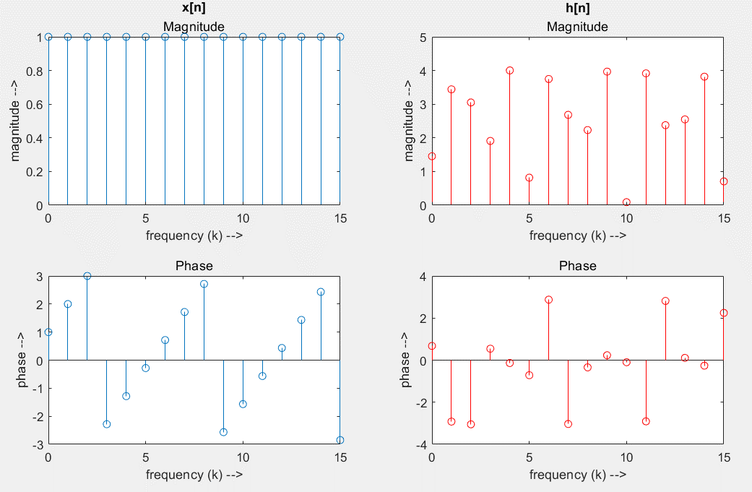

$h[n] = 4cos(5n) + j sin(2n)$

$x[n] = cos(n) + j sin(n)$

* Both functions are zero padded appropriately.

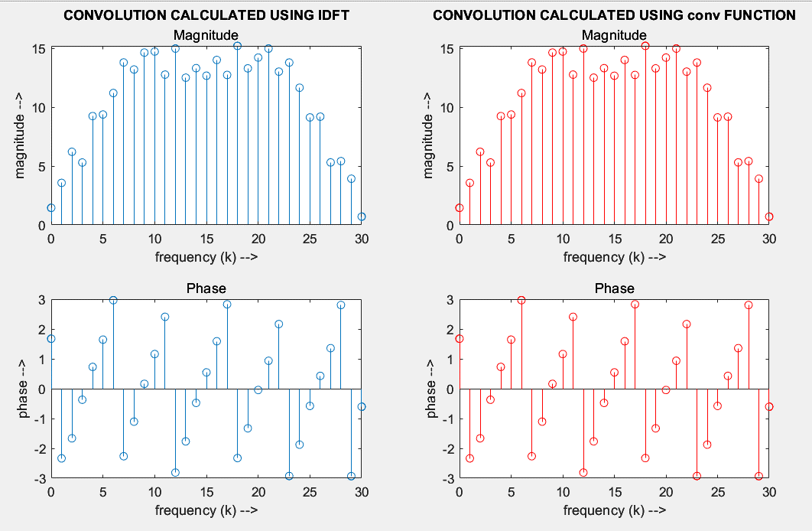

* Convolution is done by taking DFT, multiplying the results and taking IDFT. The result’s magnitude and phase plots are compared with that of the result obtained using conv function.